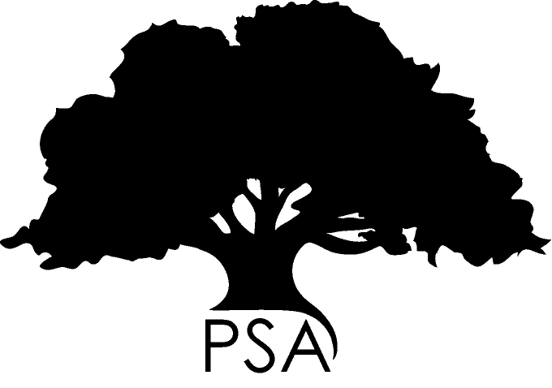**PSA Conference Travel Award Application**

| **SURNAME:** |  | **STUDENT NUMBER:** |  |
| --- | --- | --- | --- |
| **GIVEN NAMES:** |  | **TITLE:** (Ms, Mr, Dr etc) |  |

Please email of this application, with this cover sheet, to:

psa@guild.uwa.edu.au

|  |  |  |  |  |  |
| --- | --- | --- | --- | --- | --- |
| **CHECKLIST:** |  |  |  |  | |
| This coversheet | | ❑ | Confirmation of enrolment | ❑ |
| A maximum two-page CV | | ❑ | Title and proof of acceptance as speaker/presenter at intended conference | ❑ |
| Benefit of travel statement | | ❑ | A clear, accurate and itemised budget | ❑ |
|  | |  | Double checked all of the above? | ❑ |

**This coversheet:** Please include this coversheet as the front page of your application

**Confirmation of enrolment:** We require proof of enrolment. This can be found via the student connect website under confirmation link on the left.

**A maximum two-page CV:** We require a current, updated CV of no more than two pages in length

**Title and proof of acceptance:** The title of your conference paper or poster, and evidence that it has been accepted by the conference organizers. This can be from the event organizers or your supervisors.

**A clear budget:** Please outline in detail, a clear, accurate and itemized budget, indicating required resources and costs, expected additional expenses, and exactly how the PSA Award will be used. Do include a statement of other funding sources you will be using for the proposed journey. Please indicate if you will be self-funding.

**Benefit of travel statement:** A personal statement of not more than one page (typed 12pt font), highlighting the benefit of your travel to (i) your research and (ii) your future, as well as (iii) the benefits to the University. The personal statement should be comprehensible and written in terms that demonstrate an awareness of the audience assessing the application and the PSA awarding body.

**FAILURE TO INCLUDE ANY PART OF THE ABOVE CHECKLIST WILL RESULT IN THE IMMEDIATE REJECTION OF YOUR APPLICATION! PLEASE DOUBLE CHECK EVERY ITEM!**



**PSA Conference Travel Award Application**

|  |
| --- |
| **STUDENT DETAILS** |

| **SURNAME:** |  | | **STUDENT NUMBER:** | |  | | | | |
| --- | --- | --- | --- | --- | --- | --- | --- | --- | --- |
| **GIVEN NAMES:** |  | | **TITLE:** (Ms, Mr, Dr etc) | |  | | | | |
| **POSTAL ADDRESS:** | **Postcode:** | | | | | | | | |
| **TELEPHONE NO:** | **EMAIL:** | | | | | | | | |
| **SCHOOL:** |  | | | | | | | | |
| **THESIS TITLE:** |  | | | | | | | | |
| **SCHOLARSHIP/S:** |  | | | | | | | | |
| **ENROLMENT DATE:** |  |  | |  | |  | | | | |
| **DEGREE:** | Doctorate | ❑ | | Master | | ❑ | | | |
|  | Research | ❑ | | Coursework | | ❑ | | | |
|  | Full-time | ❑ | | Part-time | | ❑ | | | |
|  | | | | | | | |  | | |
| **APPLICATION SUMMARY** | | | | | | | | |  | |
| **Sum for which you are applying (maximum of $900):** | | | | | | |  | | | |
| Please indicate any other forms of support you will be receiving for this travel (specify monetary amounts): | | | | | | |  | | | |
| Have you previously received personal funding from the PSA? If so, when? | | | | | | |  | | | |
| |  |  | | --- | --- | | Have you used your Graduate Research School Travel Award and any travel funding offered by your faculty? If so, when? | | | Departure date for travel: | Return date from travel: | | | | | | | |  | | | |
| Is your paper or poster peer-reviewed? If so, please attach reviewer comments. | | | | | | |  | | | |

|  |  |  |
| --- | --- | --- |
| SIGNATURES (electronic acceptable) | | |
| *I, the applicant, declare that all information provided in this form and attached documents, is true and correct.* | |
| Applicant: | Date: |
| *I support this application, and certify that all information is correct:*  Supervisor(s): | Date: |
| *I support this application, and certify that all information is correct:*  School Graduate Research Coordinator (or) Head of School: | Date: |

**TERMS AND CONDITIONS**

If successful, payment of funds will be conditional on each recipient signing an agreement that he or she will:

* Write a 300-word report to be published in the PSA’s postgraduate magazine, *Postscript*, and on the PSA website.
* Provide receipts to the PSA equal to the value of the granted award within two weeks of the return date nominated on the application form.

**Note that applications which are incomplete (eg: lacking copies or with forms incomplete) will be ruled immediately ineligible.**

*Please visit the PSA website for information on ways the PSA can help you!*